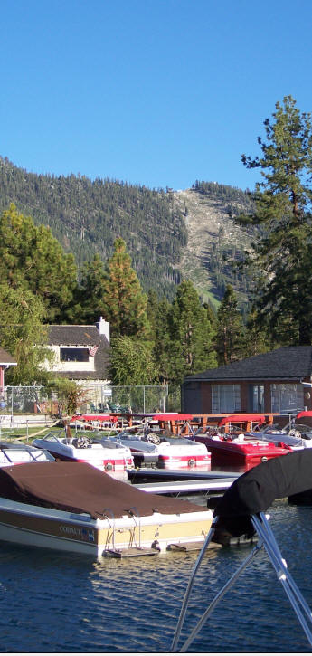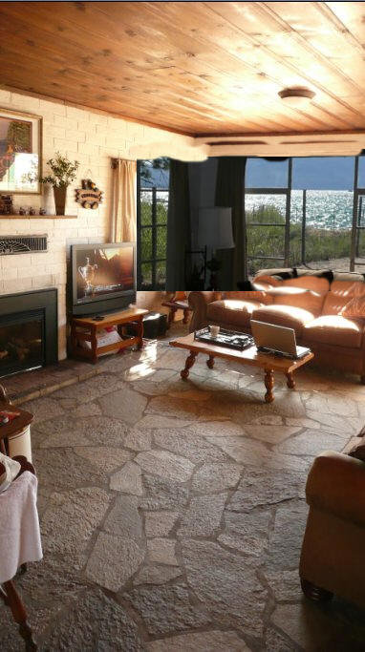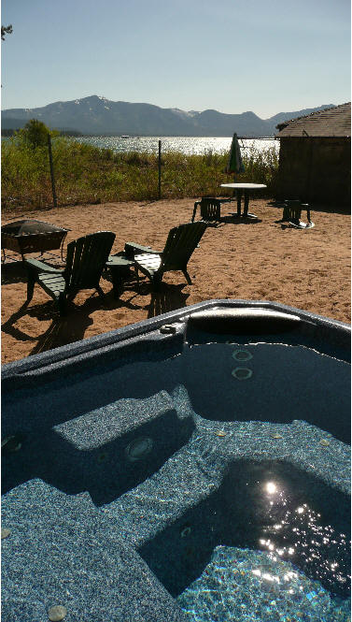
MAIN FEATURES - Tahoe Beach House:

2+ Bedrooms with sleeping loft/alcove, 2 Baths, recently remodeled. Accommodates 10.
New pillow-top Perfect Sleeper mattresses.
Flat Screen, HD TVs, cable, internet
New stainless steel appliances
On Marina at Stateline - Great Marina Rates - BRING YOUR BOAT or rent one. Like Tahoe Keys but walking distance to Casinos, Shows, Restaurants, Shops, and Gondola.
Washer and Dryer
High Speed Internet
Panoramic Lake Tahoe and Beach Views
Walk to restaurants, gondola, casinos (Harrah's, Caesar's/Montbleu, Harvey's, Horizon) shops, shows, markets, beach, marina...
Remodel completed, brand new appliances, baths, furniture, hot tub, TVs...
Private Cul-de-sac Lakeside Location
Near Edgewood Golf Course775-588-3566
Just bring your own beach towels
10% Discount at Lakeside Grill (On beach)
Carriage Rides nearby
Free appetizer at Lew Mar Nels restaurant just 1 block away.

Located on the Lakeside marina, on beautiful Lake,the exclusive use of the private lakeside park swimming beach. The location is very private, with a fenced yard. Great lake views, and a private entrance to the lakeside marina for your boat, or easy access to the rent-able amenities, ski boats, jet skis, etc.

Lots of parking on site with easy walking to casinos, heavenly gondola, or hail the horse and carriage available at your driveway. Enjoy boating and on-the-water amenities of Lake Tahoe like Tahoe Keys, Camp Richardson, and Zephyr Cove offers BUT be walking distance to all the Stateline features like shows, restaurants, Heavenly Valley Ski Area Gondola, shops, and casinos.
1-800-486-2667 1-866-SOUTHTAhoe acscom@sprynet.com

www.APlusResorts.com

